Automatic Interpretation and Orchestration (AIO)
(A theorized property of The Mind Model)
June 15, 2018

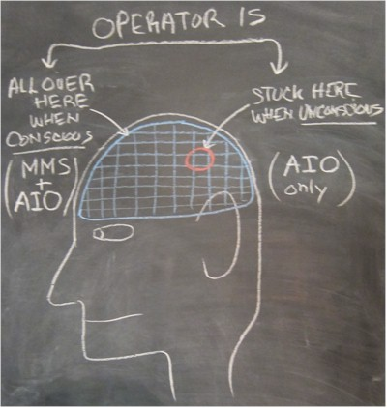
During my power walk/run today, I was thinking about my previously "invented" term, AIO, which I have chosen to explain one of the process properties of the human brain.

When one is unconscious or even "day dreaming", or "fantasizing", or "imagining". or "hallucinating" something for a short while, the "Operator" (or soul or spirit) pays little, or no, attention to sensory input. In this state, Operator mobility ceases, such that it becomes "stuck" in a sector of the brain . . . perhaps effectively unconscious.

Without access to the Brain's "Memory Management System" (MMS), only available when conscious, the entire "relational data base" of the brain is not available. But AIO is at work 24/7. It is a genetic "gift", which was pre-wired in our heads, as opposed to being learned over time. It works when the Operator can navigate the entire brain, or even when stuck in local areas.

So AIO is capable to "produce", or "stage", a sequence of imagined events or thoughts or pictures or feelings, in a little "what if play" from whatever is available from the Regional Memory information, plus whatever it can "conjure" to make the most sense. Usually limited information yields very strange results as AIO "spins" its dreams, nightmares, and imagery.

Well, so much for the speculative theory. Let's get back to my walk/run today . . .

About half way through the 3⅓ mile circuit I was feeling pretty good and I was going at my normal pace. There were only a handful of cars and dog-walkers along my route. Then, a white mini SUV went by and I noticed it was a late model Mercedes-Benz. For some reason, I imagined I was in the driver seat of that car and trying to avoid an on-coming vehicle which was encroaching on my side of the road. I took the wheel and turned sharply to the right to avoid a crash. The Mercedes responded but went into an uncontrollable 4-wheel drift. The oncoming car crashed into the driver's side of the Mercedes that I was driving. I immediately regained my awareness of reality and I went on to finish my walk/run.

So what happened? Here's my explanation . . .

For the split second I, the Operator (the one in my head that is), first focused on the Mercedes, then ceased paying attention to all perceived information, decoupled from the MMS, and observed "the show" put on by the AIO. This was essentially a day-dream and the outside world was cut off . . . for the split second.

Keep in mind that a model is not a replica of the thing one is studying. It is only a "place holder" for something we cannot define. But it is used to produce the same results as the thing we are studying. The actual understanding of the mechanism by which the Operator navigates and then uses information from the entire brain is certainly not known here. And, just how the brain can invent, orchestrate and direct a little a scenario from neuron information, that is AIO, is certainly a mystery to me. However, AIO may have something to do with human survival. In other words, if you can't understand what is perceived, AIO might provide a "menu" of possibilities to consider . . . Ha!

So that's my theory and the analysis of my observation during the event on my walk/run circuit today.

Fred Arbogast
Angels Camp, CA
http://greytrek.com

