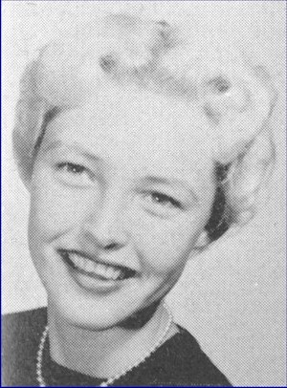
To Acalanes Classmates

"Tush" passed away on April 1, 2020 (Just like her to do it on April Fools Day!)

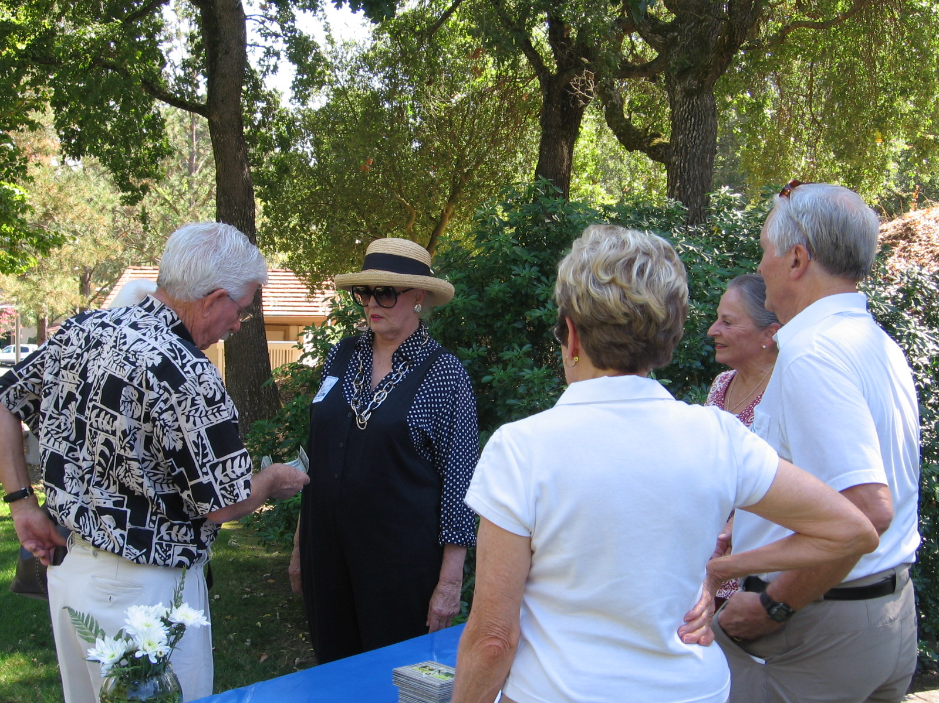
Today, Sandy and I got a call from Betty Shipley Weeks that Carol (Tush) Teuscher Ringle had passed away after a post cancer surgery relapse. She had been in Hospice care for a couple of weeks at the Carlton Assisted Living facility in Pleasant Hill. We're on the lookout for an obituary but wanted to get this in anyway.

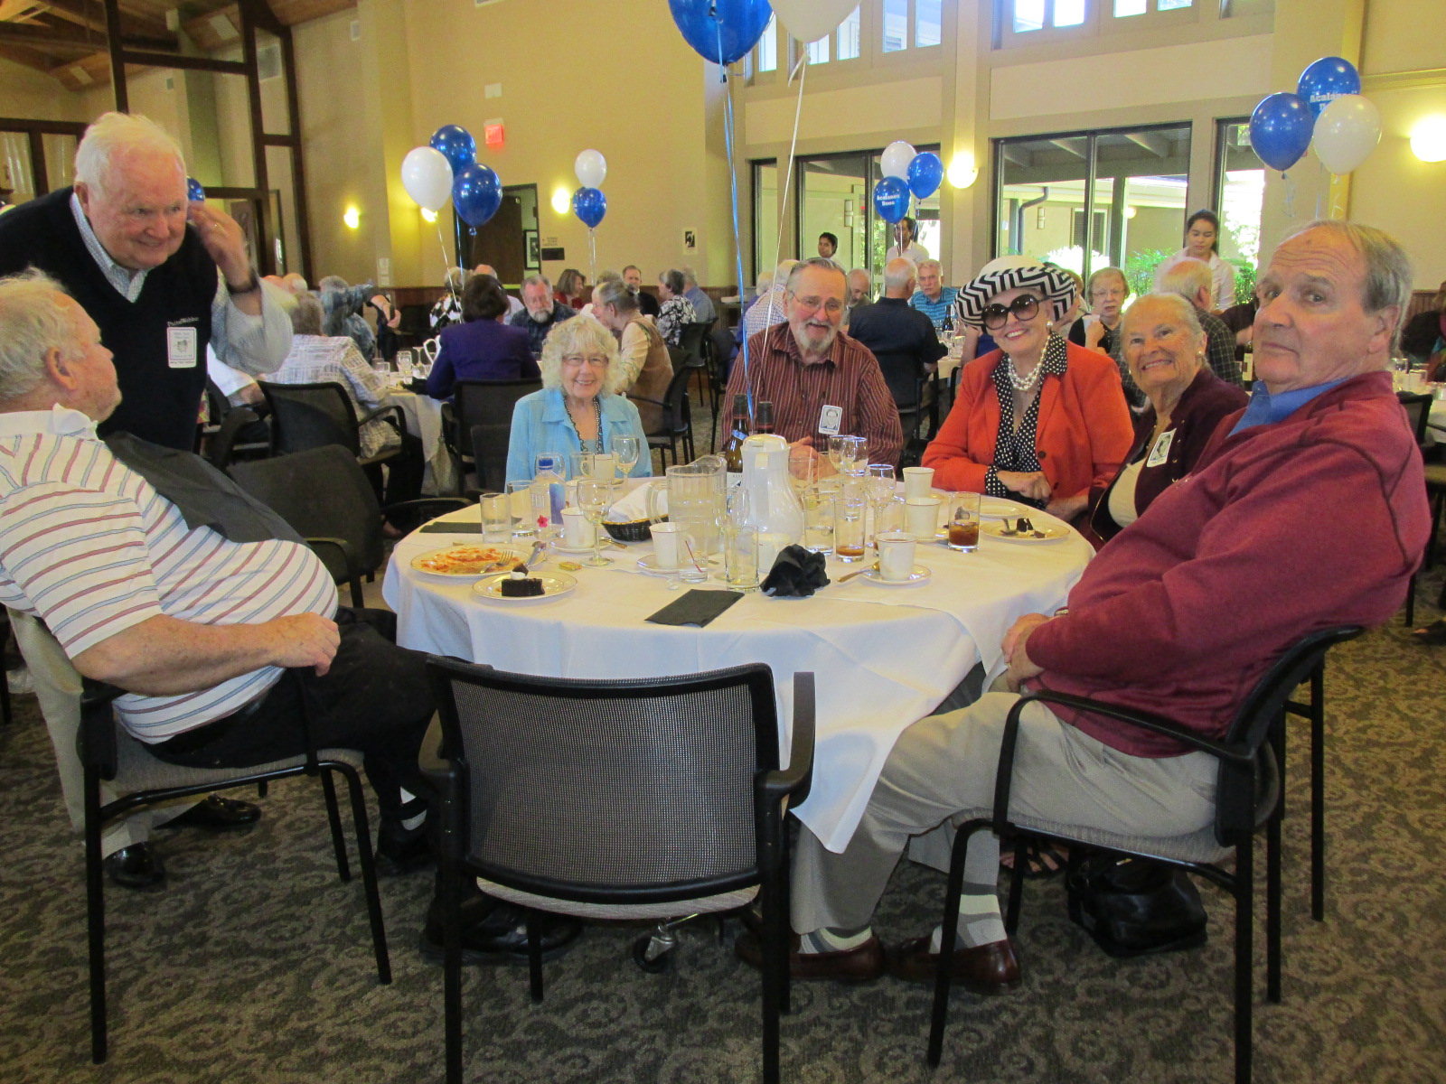
Let's pray for Tush! For years she and Pete Villa were instrumental in sustaining our great Acalanes Reunion Tradition, traveled all over the country looking for potential reunion venues, and she made calls to all of us with chat and a reunion reminder every 10 years all across the country . . . from the 40th and forward. Tush took care of our Reunion Committee's finances, including getting Mike Laurenson's fee for coming to, our 55th Year Reunion BBQ at Rossmoor unannounced . . . Ha! And the above photo's the proof!!! (see enlarged Barbecue Photos here) Tush always liked hats, and here she is sitting, hat and always glasses, with a very eclectic group at our 60th Year Reunion at Rossmoor. (see enlarged Table Photos here)

And who could forget Tush in the Junior Class Assembly in the Spring of 1955. You can explore the 1956 Aklan and see her photo (toward the back) performing with Bev Bishop as "Homer and Jethrow" with music (wish I had the record) in one of the Assemblies in our senior year.

Join us with great thoughts in celebration of our friend and classmate Carole Teuscher.

Best . . .

Fred & Sandy
http://acalanes56.com
Go Dons . . .

