Banner High Country Seniors
Presents

Cooking 101
Crock Pot

June 1, 2016

Featuring

Gary J. Bedsworth, MCFE, CFE

International Food Service Executives Association
Food Service Consultant & Consulting Chef

Table of Contents

Page 3 Getting the Most from Recipes

Page 4 Steps to a Healthier U

Page 5 F.A.S.S.

Page 6 Choose My Plate –USDA

Page 7 Kitchen Tools

Page 8 Slow Cooking

Page 9 Slow Cooking Aids & Information

Page 10 High Altitude Baking & Leftovers

Page 11 What Can We Make in A Slow Cooker?

Page 12 Sanitation & Additional References

Page 13 Biography – Gary J. Bedsworth

Getting the Most from Recipes

- Before you start, read the recipe from start to finish. You don’t want surprises after you
have started.
- Before you start to cook or bake, assemble all the necessary ingredients and equipment that
are required by the recipe.
- Prepare the ingredients according to the directions in the recipe.
- For determining doneness, always rely first on the recipe’s descriptors, such as “cook
until golden brown.” Consider any times given in a recipe merely as a guide for when to
start checking for doneness. Since in Payson we are at 5000 feet in elevation you may need
to add 25 degrees to your oven temperature and/or extend the cooking time. (See high
altitude cooking) This is especially important in baking.
- Read the recipe carefully. What does it really say?
  - Is it minced, diced, chopped, whole or quartered? Prepare the ingredient before you
start the recipe.
  - Is it 1 cup of rice cooked, or 1 cup of cooked rice? The difference is about 2 cups
  - of cooked rice and can make a big difference in a recipe.
- Have a thermometer for your oven and check the reading. Your oven reading could be off by
- 50 degrees. Also preheat your oven for 20 minutes when baking. Your oven pre-heat
sensor may also be inaccurate.
- Measure correctly:
  - ¼ tsp or 1 cup all mean level. Use a knife or spatula to level your measurement.
  - To measure flour or other dry ingredients, stir the flour and then lightly spoon it into a dry measuring cup before leveling. Don’t shake or tamp the cup before leveling unless prompted by the instruction in the recipe.
  - Be sure to measure liquid ingredients in glass or clear plastic measuring cup.

Steps to a Healthier U

If you have health concerns, ask advice from your doctor. Your doctor may ask you to visit
a Registered Dietitian for Nutrition Counseling.

In general, most of us should:

- Increase the level of fiber in our diets to 28 to 35 grams per day. Most Americans get 12 to 15 grams.

- What is good to start the day?
  - Oatmeal is always good
  - Fresh fruit
  - High fiber cereals with 6 or more grams of fiber per serving
  - Whole grain breads with 3 or more grams of fiber

- Fresh vegetables for lunch and dinner

- Fresh raw vegetables for snacks – cut out the salt and high fat dips

- Cut your sodium intake to 2000 milligrams or less.
  - How? – Don’t add extra salt at the table and limit salt during cooking.
  - Use fresh products when ever possible.
  - Read labels and purchase items with less that 350 mg of sodium. Many canned
and frozen items have 800 to 1200 milligrams of sodium per serving. Note: 1 tsp
of salt equals 2400 milligrams of sodium.

- Limit your fat and calorie intake:
  - How? –Trim your meat portions to 3 or 4 oz
  - Cut off the exterior fat before cooking
  - Cook in a non-stick pan with little or no fat
  - Leave the butter off the bread and pancakes and use reduced calorie jelly, syrup or pureed fruit.

I call these flavor adjustments “FASS™.” www.rebeccakatz.com.
FASS™ is an acronym for fat, acid, salt and sweet. Learning this culinary alchemy to custom flavor your food is the mark of a good cook and a LIFE-SAVER for people struggling to eat,
Here’s a quick picture of how FASS™ works:
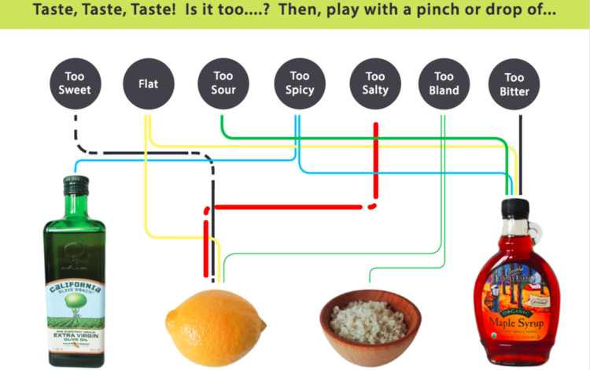

FASS™ Fixes for Troubled Taste Buds
If your taste buds are saying ______ , use this FASS™ fix:
Things have a metallic taste. Add a little sweetener, like grade B maple syrup or agave nectar, and a squeeze of lemon. You could also try adding fat, such as a nut cream or butter.
Things taste too sweet. Start by adding 6 drops of lemon or lime juice. Keep adding it in small increments until the sweet taste becomes muted.
Things taste too salty. Add ¼ teaspoon of lemon juice. It erases the taste of salt.
Things taste too bitter. Add a little sweetener, like maple syrup or agave nectar.
Everything tastes like cardboard. Add more sea salt until the flavor of the dish moves toward the front of the mouth. A spritz of fresh lemon juice also helps.
If you’re having trouble swallowing or dealing with mouth sores, add fat, such as a nut cream, to your food. Eat blended or pureed foods, such as blended soups, smoothies, and granitas. Stay away from ginger, curry, red pepper flakes, and other strong spices.
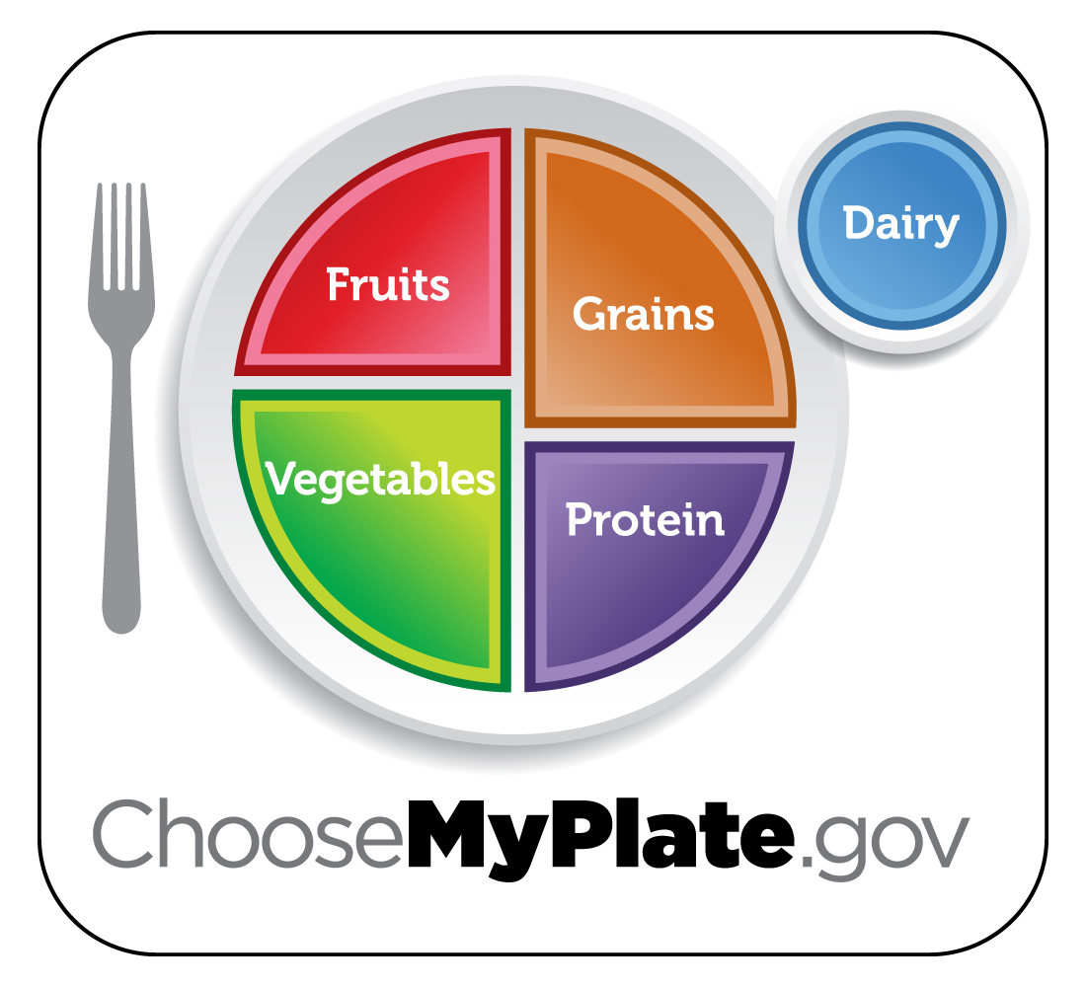
Food Groups
 |  |  |  | 
Grains Group | Vegetable Group | Fruit Group | Dairy Group | Protein Foods Group
Make at least half your grains whole. | Vary your veggies. | Focus on fruits. | Get your calcium-rich foods. | Go lean with protein.

Tips to help you:
 |  |  |  | • | Make at least half your grains whole grains
 |  |  |  | • | Vary your veggies
 |  |  |  | • | Focus on fruit
 |  |  |  | • | Get your calcium rich foods
 |  |  |  | • | Go lean with protein
 |  |  |  | • | Find your balance between food and physical activity

Kitchen Tools

- Knives, use and care
- Cutting Boards
- Peelers
- Graters & Zesters
- Liquid Measure
- Dry Measure
- Microwave – egg demo
- Barbeque
- Food Chopper
- Mixer
- Rubber Spatulas
- Whips & Mixers
- Bread Machines
- Broiler
- Ovens
- Slow Cooker – Crock Pot – Large Roaster

SLOW COOKING

Crock Pots – Ovens – Electric Roasters

Advantage –
- Slow cooking gives you TIME
- It’s easy to do, if you follow directions
- Many times you can pick up a crock pots at a thrift shop at a good price if you don’t have one.
- If you don’t have one, many are not that expensive at Walmart or other local stores
- Surprise, Surprise, you can cook just about anything in a slow cookers!

HOWEVER! You should not just dump a bunch of ingredients in a slow cookers and walk away.

For flavor and satisfaction for yourself and your family,
YOU NEED TO TAKE STEPS TO DEVELOP FLAVOR.

- Flavors – sweet, sour, salty, bitter, umani
- Aromatics – onions, garlic, shallots, herbs, spices
- Salt & Pepper – one or both are essential to develop flavor in slow cooker recipes
- Unami – Mushrooms, tomato paste, soy sauce, anchovies, tomatoes, parmesan cheese, MSG, develop a taste sensation that is meaty or savory
- Caramelization or browning – use the oven, broiler, stove (sauté) or BBQ

Slow Cookers Aids and Information

- 6-hour cooking – sometimes add vegetable in a foil packet to slow down there cooking. Like adding potatoes, the last hour of cooking.

- Foil slings – helps get bread meat out of the cookers

- Foil heat guard – the side opposite the control is hotter. For eggs ribs and some other products line that side with foil.

- Chicken should never be cooked on high or over 6 hours

- Pasta should be added raw

- There are several convenience products that can be used – frozen
potatoes, frozen onions, garlic powder, condensed cheese soup, or other soups, store bought pesto.

High Altitude Baking

Baking recipes and some other recipes developed at sea level often turn out differently at
higher altitudes. Cakes and muffins may balloon up only to collapse. Cookies might turn out thin and crisp instead of chewy, and breads may over proof and taste dry or gummy.

Why? Scientifically at 5000 feet in Payson there is a reduction in atmospheric pressure. Less pressure means that water will boil at a lower temperature and evaporate more readily in the oven. Additionally, chemical leaveners (baking soda and baking powder) or yeast will react with more force. Whipped eggs will expand more quickly and sugars will be more concentrated due to increased evaporation. Also, our homes tend to be drier unless you have a humidifier. This tends to dry out our flour.

It is generally accepted that these changes begin to affect your baking at 3500 feet and increase with elevation. If that prized old family recipe does not work in Payson:
- Increase your oven temperature 25 degrees
- Increase the liquid or eggs in your recipe
- Under whipping eggs may help
- Reduce the amount of sugar
- Try adding a tablespoon of water to your dough

Unfortunately, it is impossible to write hard and fast rules. Each recipe may have its’ own set of problems. Baking in Payson may require some trial and error.

Leftovers

I’ve been cooking for two for over 30 years. I almost always prepare extra to enjoy at another meal with my wife. However, many times I will rework an item to serve in a different form or with a sauce. For instance, a pot roast will last many days and may be served in its original form or as sandwich meat hot or cold, beef hash, or in beef and vegetable stew.

The primary concern with leftovers is that they be stored properly. It is recommended that you cool them to get closer to room temperature, place them in the refrigerator uncovered, until they chill, then wrap them for storage. Cooled and stored properly leftovers can last several days.

What Can We Make in a Slow Cooker?

- Risotto, polenta, poultry stuffing, mashed potatoes, gravy, side dishes
- 7 pound turkey breast
- Chicken and dumplings
- Maple glazed pork loin
- Tex-mex stuffed peppers
- BBQ ribs
- Soups
- Chili
- Whole chicken in a pot
- Breakfast strata
- Pesto meat balls
- Meat loaf
- And on and on!

Sanitation

Sanitation is critical to your continued enjoyment of food. A few basics follow:

- Wash your hands frequently. You don’t need anti-bacterial soap.
- Use a cutting board. Have several and change them when you are working with meat then vegetable or other food items. Its preferable to start with the vegetables then cut the meat. Always wash your work surface or cutting board after working with raw chicken, turkey, or fish.
- Cooking above 135 degrees F kills most bacteria. The minimum temperature on pork is 145 degrees F. However, Chicken and leftovers should be cooked to 165 degrees.
- For all practical purposes the rule should be three days and out. However, many items if properly cooked, chilled and stored will last longer, possibly up to 7 days.
- Most protein items will tend to deteriorate after 3 days of storage. If it lasts more that 3 days, next time see if you can cut your recipe back or freeze part of it for future use.
- The human scalp looses thousands of hairs each day. If you don’t want unsightly hair in your food wear a cap.
- Change that sink dishcloth or sponge. They harbor bacteria and should be washed frequently.
- Wash all produce. Many produce items may contain pesticides and or residual soil from the fields.

Additional References
Payson has an almost unlimited reference. It is the Payson Library. The Payson Library has dozens of cookbooks and magazines available to use, read in the library or take home and
study. Everything you ever wanted to know about food and cooking is available for your review. Ask the staff. They are very helpful.

They also have computers available for your use. If you are not computer literate, bring a friend to guide you to great recipe sources like:

www.cooksillustrated.com
www.epicurious.com
www.allrecipes.com
www.cooks.com
www.mypramid.gov
www.rebeccakatz.com

Beef stew with red wine
First we focused on which cut of beef would work best in our slow-cooker beef stew recipe, ruling out top and bottom round because of their leanness, and prepackaged beef chunks because their irregular shapes made for inconsistent results. We chose chuck roast because it was flavorful, tender, and juicy, and we cut it into chunks ourselves. While we recognize that slow-cooker stew recipes are meant to be easier to prepare and more convenient, searing the meat is a key step vital to the quality of the stew. It takes only minutes (and can be done the night before) and builds the flavor foundation of the stew by leaving caramelized bits on the skillet bottom that can be incorporated into the stew by a quick deglazing with broth or wine.
RECIPE

5 pounds boneless beef chuck-eye roast, trimmed and cut into 1 ½-inch cubes (see illustrations below)
Salt and ground black pepper
2tablespoons vegetable oil
2medium onions, chopped medium
3medium garlic cloves, minced or pressed through a garlic press
1cup dry red wine
2cups low-sodium chicken broth
2cups low-sodium beef broth
1teaspoon dried thyme
2bay leaves
2pounds Red Bliss potatoes (about 6 medium), scrubbed
5medium carrots, peeled and cut into 1-inch chunks
½cup all-purpose flour
1cup frozen peas, thawed
2tablespoons minced fresh parsley leaves

INSTRUCTIONSSERVES 6 TO 8
To keep the potatoes from falling apart during the long cooking time, put them into the slow cooker whole and nestle them around the edges of the cooker, where the heating coils reside. This recipe takes 9 to 10 hours on the slow cooker's low setting or 6 to 7 hours on its high setting.
1. Dry the beef thoroughly with paper towels, then season generously with salt and pepper. Heat 2 teaspoons of the oil in a 12-inch skillet over medium-high heat until just smoking. Distribute half of the beef in the skillet and cook, without stirring, until well browned on one side, about 4 minutes. Stir the meat and continue to cook, stirring occasionally, until completely browned, 4 to 6 minutes longer. Transfer it to a slow cooker. Return the skillet to medium-high heat and heat 2 more teaspoons oil until just smoking. Brown the remaining beef and transfer it to the slow cooker.
2. Return the skillet to medium heat and heat the remaining 2 teaspoons oil until shimmering. Add the onions and ¼ teaspoon salt; cook, stirring occasionally, until the onions are softened and lightly browned, about 5 minutes. Add the garlic and cook until fragrant, about 30 seconds. Add the red wine; turn the heat to high and bring to a boil, scraping the browned bits off the skillet bottom. Pour into the slow cooker.
3. Stir the chicken broth, 1½ cups of the beef broth, thyme, and bay leaves into the slow cooker. Following the illustrations below, nestle the potatoes and carrots around the edges of the slow cooker. Cover and cook, on either low or high, until the meat is tender, 9 to 10 hours on low or 6 to 7 hours on high.
4. When the meat is tender, remove the potatoes using a slotted spoon and transfer to a carving board; allow them to cool slightly. Set the slow cooker to high (if necessary). Whisk the flour with the remaining ½ cup beef broth until smooth, then stir into the slow cooker. Quarter the potatoes and return them to the slow cooker. Continue to cook on high until the sauce is thickened and no longer tastes of flour, 10 to 15 minutes longer. Stir in the peas and parsley. Season to taste with salt and pepper before serving.

STEP-BY-STEP

Cutting Stew Meat
For stew meat pieces that are cut from the right part of the animal and regularly shaped, we suggest buying a boneless roast and cutting the meat yourself. A 3-pound roast will yield about 2 1/2 pounds of beef, perfect for searing in two batches.
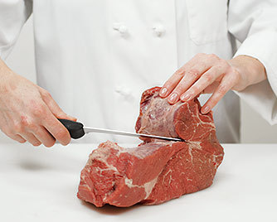
1. Pull apart the roast at its major seams (delineated by lines of fat and silver skin). Use a knife as necessary.
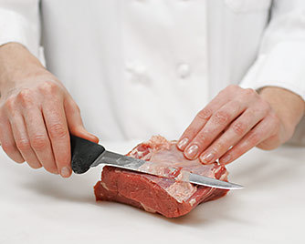
2. With a knife, trim off excess fat and silver skin.
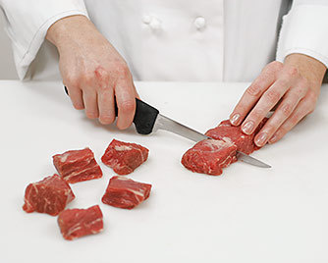
3. Cut the meat into cubes or chunks as directed in specific recipes.

RECIPE TESTING

Arranging the Vegetables in a Slow Cooker
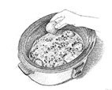
In recipes where the meat is only in the slow cooker for 4 to 5 hours, it is important to arrange the vegetables around the edges of the slow cooker, nearer the heating elements, so that they will cook evenly. Also, this technique is useful in recipes where potatoes are added whole to the stew.

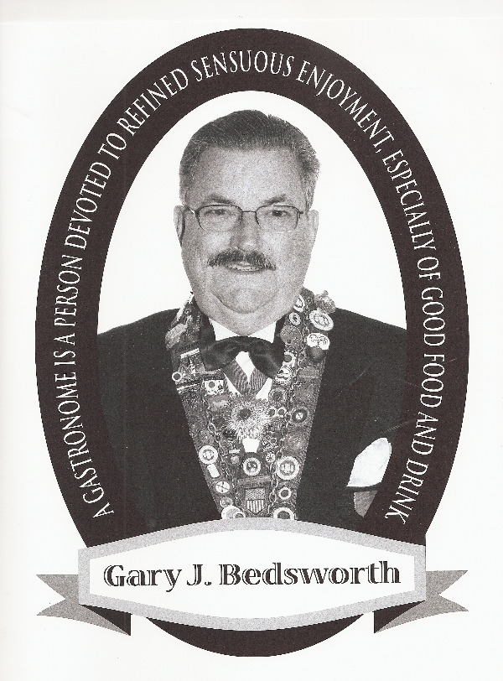
Biographical Information
Gary J. Bedsworth

Mr. Bedsworth retired after 40 + years in the hospitality industry. He has both culinary and AA degrees from the City College of San Francisco, and a BA degree in Business and Hospitality Management from Michigan State University. He has worked with numerous European and American Chefs and won several national honors.

Mr. Bedsworth has experienced a very diverse management career: Restaurants, Private Clubs, Hotels, Catering, Health Care, Management Consulting, and Consulting Chef. His management responsibilities have ranged from small restaurants to multi million-dollar system general management. He has been semi retired since January 2001.

In Arizona, Mr. Bedsworth served as System Director of Food & Nutrition Services for the Samaritan Health Care System in Phoenix and Tucson Medical Center.

Mr. Bedsworth also served three terms in Florida as President of the Lee, Collier and Charlotte County Restaurant Association and served as a member of the Board of Directors of the Florida Restaurant Association. During his career he received awards from the Florida Restaurant Association, National Restaurant Association, Society for Off Premise Catering, and the Marion E. Wade Memorial Award as the most outstanding healthcare food operation in the country.

